How does java Hashmap work internally
Posted by Dinesh Rajput
What is Hashing?
Hashing in its simplest form, is a way to assigning a unique code for any variable/object after applying any formula/algorithm on its properties. A true Hashing function must follow this rule:
Hash function should return the same hash code each and every time, when function is applied on same or equal objects. In other words, two equal objects must produce same hash code consistently.
Note: All objects in java inherit a default implementation of hashCode() function defined in Object class. This function produce hash code by typically converting the internal address of the object into an integer, thus producing different hash codes for all different objects.
HashMap is an array of Entry objects:
Consider HashMap as just an array of objects.
Have a look what this Object is:
view plainprint?
- static class Entry<K,V> implements Map.Entry<K,V> {
- final K key;
- V value;
- Entry<K,V> next;
- final int hash;
- ...
- }
Each Entry object represents key-value pair. Field next refers to other Entry object if a bucket has more than 1 Entry.
Sometimes it might happen that hashCodes for 2 different objects are the same. In this case 2 objects will be saved in one bucket and will be presented as LinkedList. The entry point is more recently added object. This object refers to other object with next field and so one. Last entry refers to null.
When you create HashMap with default constructor
view plainprint?
- HashMap hashMap = new HashMap();
Array is gets created with size 16 and default 0.75 load balance.
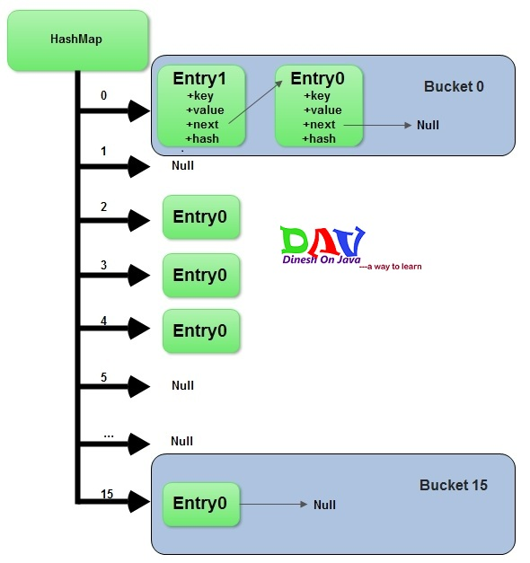

Adding a new key-value pair
- Calculate hashcode for the key
- Calculate position hash % (arrayLength-1)) where element should be placed(bucket number)
- If you try to add a value with a key which has already been saved in HashMap, then value gets overwritten.
- Otherwise element is added to the bucket. If bucket has already at least one element - a new one is gets added and placed in the first position in the bucket. Its next field refers to the old element.
Deletion:
- Calculate hashcode for the given key
- Calculate bucket number (hash % (arrayLength-1))
- Get a reference to the first Entry object in the bucket and by means of equals method iterate over all entries in the given bucket. Eventually we will find correct Entry. If desired element is not found - return null
What put() method actually does:
Before going into put() method’s implementation, it is very important to learn that instances of Entry class are stored in an array.HashMap class defines this variable as:
view plainprint?
- /**
- * The table, resized as necessary. Length MUST Always be a power of two.
- */
- transient Entry[] table;
Now look at code implementation of put() method:
view plainprint?
- /**
- * Associates the specified value with the specified key in this map. If the
- * map previously contained a mapping for the key, the old value is
- * replaced.
- *
- * @param key
- * key with which the specified value is to be associated
- * @param value
- * value to be associated with the specified key
- * @return the previous value associated with <tt>key</tt>, or <tt>null</tt>
- * if there was no mapping for <tt>key</tt>. (A <tt>null</tt> return
- * can also indicate that the map previously associated
- * <tt>null</tt> with <tt>key</tt>.)
- */
- public V put(K key, V value) {
- if (key == null)
- return putForNullKey(value);
- int hash = hash(key.hashCode());
- int i = indexFor(hash, table.length);
- for (Entry<k , V> e = table[i]; e != null; e = e.next) {
- Object k;
- if (e.hash == hash && ((k = e.key) == key || key.equals(k))) {
- V oldValue = e.value;
- e.value = value;
- e.recordAccess(this);
- return oldValue;
- }
- }

- modCount++;
- addEntry(hash, key, value, i);
- return null;
- }
Lets note down the steps one by one:
Step1- First of all, key object is checked for null. If key is null, value is stored in table[0] position. Because hash code for null is always 0.
Step2- Then on next step, a hash value is calculated using key’s hash code by calling its hashCode() method. This hash value is used to calculate index in array for storing Entry object. JDK designers well assumed that there might be some poorly writtenhashCode() functions that can return very high or low hash code value. To solve this issue, they introduced another hash() function, and passed the object’s hash code to this hash() function to bring hash value in range of array index size.
Step3- Now indexFor(hash, table.length) function is called to calculate exact index position for storing the Entry object.
Step4- Here comes the main part. Now, as we know that two unequal objects can have same hash code value, how two different objects will be stored in same array location [called bucket].
Answer is LinkedList. If you remember, Entry class had an attribute “next”. This attribute always points to next object in chain. This is exactly the behavior of LinkedList.
So, in case of collision, Entry objects are stored in LinkedList form. When an Entry object needs to be stored in particular index, HashMap checks whether there is already an entry?? If there is no entry already present, Entry object is stored in this location.
If there is already an object sitting on calculated index, its next attribute is checked. If it is null, and current Entry object becomes next node in LinkedList. If next variable is not null, procedure is followed until next is evaluated as null.
What if we add the another value object with same key as entered before. Logically, it should replace the old value. How it is done? Well, after determining the index position of Entry object, while iterating over LinkedList on calculated index, HashMap calls equals method on key object for each Entry object. All these Entry objects in LinkedList will have similar hash code but equals() method will test for true equality. If key.equals(k) will be true then both keys are treated as same key object. This will cause the replacing of value object inside Entry object only.
In this way, HashMap ensure the uniqueness of keys.
How get() methods works internally
Now we have got the idea, how key-value pairs are stored in HashMap. Next big question is : what happens when an object is passed in get method of HashMap? How the value object is determined?
Answer we already should know that the way key uniqueness is determined in put() method , same logic is applied in get() method also. The moment HashMap identify exact match for the key object passed as argument, it simply returns the value object stored in current Entry object.
If no match is found, get() method returns null.
Let have a look at code:
view plainprint?
- /**
- * Returns the value to which the specified key is mapped, or {@code null}
- * if this map contains no mapping for the key.
- *
- * <p>
- * More formally, if this map contains a mapping from a key {@code k} to a
- * value {@code v} such that {@code (key==null ? k==null :
- * key.equals(k))}, then this method returns {@code v}; otherwise it returns
- * {@code null}. (There can be at most one such mapping.)
- *
- * </p><p>
- * A return value of {@code null} does not <i>necessarily</i> indicate that
- * the map contains no mapping for the key; it's also possible that the map
- * explicitly maps the key to {@code null}. The {@link #containsKey
- * containsKey} operation may be used to distinguish these two cases.
- *
- * @see #put(Object, Object)
- */
- public V get(Object key) {
- if (key == null)
- return getForNullKey();
- int hash = hash(key.hashCode());
- for (Entry<k , V> e = table[indexFor(hash, table.length)]; e != null; e = e.next) {
- Object k;
- if (e.hash == hash && ((k = e.key) == key || key.equals(k)))
- return e.value;
- }
- return null;
- }

How Hashmap works in Java
HashMap works on the principle of Hashing . To understand Hashing , we should understand the three terms first i.e Hash Function , Hash Value and Bucket .
What is Hash Function , Hash Value and Bucket ?
hashCode() function which returns an integer value is the Hash function. The important point to note that , this method is present in Object class ( Mother of all class ) .
This is the code for the hash function(also known as hashCode method) in Object Class :
public native int hashCode();

The most important point to note from the above line : hashCode method return int value .
So the Hash value is the int value returned by the hash function .
So summarize the terms in the diagram below :
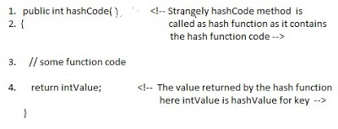
What is bucket ?
A bucket is used to store key value pairs . A bucket can have multiple key-value pairs . In hash map, bucket used simple linked list to store objects .
After understanding the terms we are ready to move next step , How hash map works in java or How get() works internally in java .
Code inside Java Api (HashMap class internal implementation) for HashMap get(Obejct key) method
1. Public V get(Object key)
{
2. if (key ==null)
3. //Some code

4. int hash = hash(key.hashCode());

5. // if key found in hash table then return value
6. // else return null
}
Hash map works on the principle of hashing
HashMap get(Key k) method calls hashCode method on the key object and applies returned hashValue to its own static hash function to find a bucket location(backing array) where keys and values are stored in form of a nested class called Entry (Map.Entry) . So you have concluded that from the previous line that Both key and value is stored in the bucket as a form of Entry object . So thinking that Only value is stored in the bucket is not correct and will not give a good impression on the interviewer .
* Whenever we call get( Key k ) method on the HashMap object . First it checks that whether key is null or not . Note that there can only be one null key in HashMap .
If key is null , then Null keys always map to hash 0, thus index 0.
If key is not null then , it will call hashfunction on the key object , see line 4 in above method i.e. key.hashCode() ,so after key.hashCode() returns hashValue , line 4 looks like
4. int hash = hash(hashValue)
, and now ,it applies returned hashValue into its own hashing function .
We might wonder why we are calculating the hashvalue again using hash(hashValue). Answer is ,It defends against poor quality hash functions.
Now step 4 final hashvalue is used to find the bucket location at which the Entry object is stored . Entry object stores in the bucket like this (hash,key,value,bucketindex) .
Interviewer: What if when two different keys have the same hashcode ?
Solution, equals() method comes to rescue. Here candidate gets puzzled. Since bucket is one and we have two objects with the same hashcode .Candidate usually forgets that bucket is a simple linked list.
The bucket is the linked list effectively . Its not a LinkedList as in a java.util.LinkedList - It's a separate (simpler) implementation just for the map .
So we traverse through linked list , comparing keys in each entries using keys.equals() until it return true. Then the corresponding entry object Value is returned .
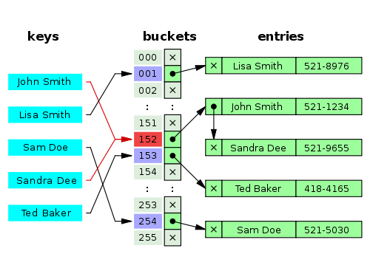
One of our readers Jammy asked a very good question
When the functions 'equals' traverses through the linked list does it traverses from start to end one by one...in other words brute method. Or the linked list is sorted based on key and then it traverses?
Answer is when an element is added/retrieved, same procedure follows:
a. Using key.hashCode() [ see above step 4],determine initial hashvalue for the key
b. Pass intial hashvalue as hashValue in hash(hashValue) function, to calculate the final hashvalue.
c. Final hash value is then passed as a first parameter in the indexFor(int ,int )method .
The second parameter is length which is a constant in HashMap Java Api , represented by DEFAULT_INITIAL_CAPACITY
The default value of DEFAULT_INITIAL_CAPACITY is 16 in HashMap Java Api .
indexFor(int,int) method returns the first entry in the appropriate bucket. The linked list in the bucket is then iterated over - (the end is found and the element is added or the key is matched and the value is returned )
Explanation about indexFor(int,int) is below :
/**
* Returns index for hash code h.
*/
static int indexFor(int h, int length) {
return h & (length-1);
}
The above function indexFor() works because Java HashMaps always have a capacity, i.e. number of buckets, as a power of 2.
Let's work with a capacity of 256,which is 0x100, but it could work with any power of 2. Subtracting 1
from a power of 2 yields the exact bit mask needed to bitwise-and with the hash to get the proper bucket index, of range 0 to length - 1.
256 - 1 = 255
0x100 - 0x1 = 0xFF
E.g. a hash of 257 (0x101) gets bitwise-anded with 0xFF to yield a bucket number of 1.
Interviewer: What if when two keys are same and have the same hashcode ?
If key needs to be inserted and already inserted hashkey's hashcodes are same, and keys are also same(via reference or using equals() method) then override the previous key value pair with the current key value pair.
The other important point to note is that in Map ,Any class(String etc.) can serve as a key if and only if it overrides the equals() and hashCode() method .

Interviewer: How will you measure the performance of HashMap?
According to Oracle Java docs,
An instance of HashMap has two parameters that affect its performance: initial capacity and load factor.
The capacity is the number of buckets in the hash table( HashMap class is roughly equivalent to Hashtable, except that it is unsynchronized and permits nulls.), and the initial capacity is simply the capacity at the time the hash table is created.
The load factor is a measure of how full the hash table is allowed to get before its capacity is automatically increased. When the number of entries in the hash table exceeds the product of the load factor and the current capacity, the hash table is rehashed (that is, internal data structures are rebuilt) so that the hash table has approximately twice the number of buckets.
In HashMap class, the default value of load factor is (.75) .
Interviewer : What is the time complexity of Hashmap get() and put() method ?
The hashmap implementation provides constant time performance for (get and put) basic operations
i.e the complexity of get() and put() is O(1) , assuming the hash function disperses the elements properly among the buckets.

HashSet:
HashSet implements Set interface which does not allow duplicate value.It is not synchronized and is not thread safe.
Definition of duplicate can be quite tricky sometimes.Lets consider two cases here.
- In case of primitive types(such as interger, String)
- In case of custom defined objects.
In case of primitive types:
In case of primitives type, it is very straight forward.Lets see with help of example:
Lets create a java program:
view plainprint?
- package org.arpit.java2blog;
- import java.util.HashSet;

- public class HashSetMain {

- public static void main(String[] args) {
- HashSet<String> nameSet=new HashSet<String>();
- nameSet.add("Arpit");
- nameSet.add("Arpit");
- nameSet.add("john");
- System.out.println("size of nameSet="+nameSet.size());
- System.out.println(nameSet);
- }

- }
When you run above program, you will get following output:
view plainprint?
- size of nameSet=2
- [Arpit, john]
So we tried to add String "Arpit" twice, but as HashSet does not allow duplicate value, it will add "Arpit" once in HashSet
In case of Custom Objects:
For understanding how HashSet will work in case of custom objects, you need to understand hashcode and equals method in java.Lets create a class called Country and implement only equals method in it.
view plainprint?
- package org.arpit.java2blog;

- public class Country {

- String name;
- long population;
- public String getName() {
- return name;
- }
- public void setName(String name){
- this.name = name;
- }
- public long getPopulation() {
- return population;
- }
- public void setPopulation(long population) {
- this.population = population;
- }

- public String toString()
- {
- return name;
- }
- @Override
- public boolean equals(Object obj) {
- if (this == obj)
- return true;
- if (obj == null)
- return false;
- if (getClass() != obj.getClass())
- return false;
- Country other = (Country) obj;
- if (name == null) {
- if (other.name != null)
- return false;
- } else if (!name.equals(other.name))
- return false;
- return true;
- }

- }
create main class:
view plainprint?
- package org.arpit.java2blog;

- import java.util.HashSet;

- public class HashSetCountryMain {

- public static void main(String[] args)
- {
- HashSet<Country> countrySet=new HashSet<Country>();
- Country india1=new Country();
- india1.setName("India");

- Country india2=new Country();
- india2.setName("India");

- countrySet.add(india1);
- countrySet.add(india2);

- System.out.println("size of nameSet="+countrySet.size());
- System.out.println(countrySet);

- }
- }
When you run above program, you will get following output:
view plainprint?
- size of nameSet=2
- [India, India]
Now you must be wondering even through two objects are equal why HashSet contains two values instead of one.This is because First HashSet calculates hashcode for that key object, if hashcodes are same then only it checks for equals method and because hashcode for above two country objects uses default hashcode method,Both will have different memory address hence different hashcode.
Now lets add hashcode method in above Country class
view plainprint?
- @Override
- public int hashCode() {
- final int prime = 31;
- int result = 1;
- result = prime * result + ((name == null) ? 0 : name.hashCode());
- return result;
- }
Run above main program again, you will get following output:
view plainprint?
- size of nameSet=1
- [India]
So now we have good understanding of HashSet, lets see its internal representation:

Internal working of HashSet:
When you add any duplicate element to HashSet, add() method returns false and do not add duplicate element to HashSet.
How add method return false? For this, we need to see HashSet's add method in JavaAPI
view plainprint?
- public class HashSet<E>
- extends AbstractSet<E>
- implements Set<E>, Cloneable, java.io.Serializable
- {

- private transient HashMap<E,Object> map;

- // PRESENT is dummy value which will be used as value in map
- private static final Object PRESENT = new Object();

- /**
- * Constructs a empty map.so hash
- *
- */
- public HashSet() {
- map = new HashMap<E,Object>();
- }

- // return false if e is already present in HashSet
- public boolean add(E e) {
- return map.put(e, PRESENT)==null;
- }

- // other HashSet methods
- }
So from above code, It is clear that HashSet uses HashMap for checking duplicate elements.As we know that in HashMap , key should be unique. So HashSet uses this concept, When element is added to HashSet, it is added to internal HashMap as Key.This HashMap required some value so a dummy Object(PRESENT) is used as value in this HashMap.
PRESENT is dummy value which is used value for internal map.
Lets see add method:
view plainprint?
- // return false if e is already present in HashSet
- public boolean add(E e) {
- return map.put(e, PRESENT)==null;
- }
So here there will be two cases
- map.put(e,PRESENT) will return null, if element not present in that map. So map.put(e, PRESENT) == null will return true ,hence add method will return true and element will be added in HashSet.
- map.put(e,PRESENT) will return old value ,if element is already present in that map. So map.put(e, PRESENT) == null will return false, hence add method will return false and element will not be added in HashSet.

Set Implementation Internally in Java
Each and every element in the set is unique . So that there is no duplicate element in set .
So in java if we want to add elements in the set then we write code like this
public class JavaHungry {

public static void main(String[] args)
{
// TODO Auto-generated method stub

HashSet<Object> hashset = new HashSet<Object>();
hashset.add(3);
hashset.add("Java Hungry");
hashset.add("Blogspot");
System.out.println("Set is "+hashset);
}
}
It will print the result : Set is [3, Java Hungry, Blogspot]
Now let add duplicate element in the above code
public class JavaHungry {

public static void main(String[] args)
{
HashSet<Object> hashset = new HashSet<Object>();
hashset.add(3);
hashset.add("Java Hungry");
hashset.add("Blogspot");
hashset.add(3); // duplicate elements
hashset.add("Java Hungry"); // duplicate elements
System.out.println("Set is "+hashset);
}
}
It will print the result : Set is [3, Java Hungry, Blogspot]
Now , what happens internally when you pass duplicate elements in the add() method of the Set object , It will return false and do not add to the HashSet , as the element is already present .So far so good .
But the main problem arises that how it returns false . So here is the answer
When you open the HashSet implementation of the add() method in Java Apis that is rt.jar , you will find the following code in it
public class HashSet<E>
extends AbstractSet<E>
implements Set<E>, Cloneable, java.io.Serializable

{
private transient HashMap<E,Object> map;

// Dummy value to associate with an Object in the backing Map

private static final Object PRESENT = new Object();

public HashSet() {
map = new HashMap<>();
}

// SOME CODE ,i.e Other methods in Hash Set

public boolean add(E e) {
return map.put(e, PRESENT)==null;
}

// SOME CODE ,i.e Other methods in Hash Set
}
So , we are achieving uniqueness in Set,internally in java through HashMap . Whenever you create an object of HashSet it will create an object of HashMap as you can see in the italic lines in the above code .
We already discussed How HashMap works internally in java .
As we know in HashMap each key is unique . So what we do in the set is that we pass the argument in the add(Elemene E) that is E as a key in the HashMap . Now we need to associate some value to the key , so what Java apis developer did is to pass the Dummy value that is ( new Object () ) which is referred by Object reference PRESENT .
So , actually when you are adding a line in HashSet like hashset.add(3) what java does internally is that it will put that element E here 3 as a key in the HashMap(created during HashSet object creation) and some dummy value that is Object's object is passed as a value to the key .

2) Difference between HashMap and ConcurrentHashMap
To better visualize the ConcurrentHashMap, let it consider as a group of HashMaps. To get and put key-value pairs from hashmap, you have to calculate the hashcode and look for correct bucket location in array of Collection.Entry. Rest you have read on previous related article on how hashmap works.
In concurrentHashMap, the difference lies in internal structure to store these key-value pairs. ConcurrentHashMap has an addition concept of segments. It will be easier to understand it you think of one segment equal to one HashMap [conceptually]. A concurrentHashMap is divided into number of segments [default 16] on initialization. ConcurrentHashMap allows similar number (16) of threads to access these segments concurrently so that each thread work on a specific segment during high concurrency.
This way, if when your key-value pair is stored in segment 10; code does not need to block other 15 segments additionally. This structure provides a very high level of concurrency.
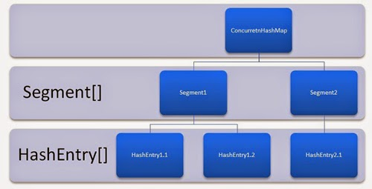

ConcurrentHashMap Internal Structure
In other words, ConcurrentHashMap uses a multitude of locks, each lock controls one segment of the map. When setting data in a particular segment, the lock for that segment is obtained. So essentially update operations are synchronized.
When getting data, a volatile read is used without any synchronization. If the volatile read results in a miss, then the lock for that segment is obtained and entry is again searched in synchronized block.
I will go further deeper into this concept in my coming post. I will suggest you to subscribe email updates to get notified.

3) Difference between HashMap and Collections.synchronizedMap(HashMap)
It’s easy question, right !! HashMap is non-synchronized and Collections.synchronizedMap() returns a wrapped instance of HashMap which has all get, put methods synchronized.
Essentially, Collections.synchronizedMap() returns the reference of internally created inner-class “SynchronizedMap”, which contains key-value pairs of input HashMap, passed as argument.
This instance of inner class has nothing to do with original parameter HashMap instance and is completely independent.

4) Difference between ConcurrentHashMap and Collections.synchronizedMap( HashMap )
This one is slightly tougher. Both are synchronized version of HashMap, with difference in their core functionality and internal structure.
As stated above, ConcurrentHashMap is consist of internal segments which can be viewed as independent HashMaps, conceptually. All such segments can be locked by separate threads in high concurrent executions. In this way, multiple threads can get/put key-value pairs from ConcurrentHashMap without blocking/waiting for each other.
In Collections.synchronizedMap(), we get a synchronized version of HashMap and it is accessed in blocking manner. This means if multiple threads try to access synchronizedMap at same time, they will be allowed to get/put key-value pairs one at a time in synchronized manner.

5) Difference between HashMap and HashTable
It is also very easy question. The major difference is that HashTable is synchronized and HashMap is not.
If asked for other reasons, tell them, HashTable is legacy class (part of JDK 1.0) which was promoted into collections framework by implementing Map interface later. It still has some extra features like Enumerator with it, which HashMap lacks.
Another minor reason can be: HashMap supports null key (mapped to zero bucket), HashTable does not support null keys and throws NullPointerException on such attempt.

6) Difference between HashTable and Collections.synchronized(HashMap)
So far you must have got the core idea of the similarities between them. Both are synchronized version of collection. Both have synchronized methods inside class. Both are blocking in nature i.e. multiple threads will need to wait for getting the lock on instance before putting/getting anything out of it.
So what is the difference. Well, NO major difference for above said reasons. Performance is also same for both collections.
Only thing which separates them is the fact HashTable is legacy class promoted into collection framework. It got its own extra features like enumerators.

7) Impact of random/fixed hashcode() value for key
The impact of both cases (fixed hashcode or random hashcode for keys) will have same result and that is “unexpected behavior“. The very basic need of hashcode in HashMap is to identify the bucket location where to put the key-value pair, and from where it has to be retrieved.
If the hashcode of key object changes every time, the exact location of key-value pair will be calculated different, every time. This way, one object stored in HashMap will be lost forever and there will be very minimum possibility to get it back from map.
For this same reason, key are suggested to be immutable, so that they return a unique and same hashcode each time requested on same key object.

8) Using HashMap in non-synchronized code in multi-threaded application
In normal cases, it can leave the hashmap in inconsistent state where key-value pairs added and retrieved can be different. Apart from this, other surprising behavior like NullPointerException can come into picture.
In worst case, It can cause infinite loop. YES. You got it right. It can cause infinite loop. What did you asked, How?? Well, here is the reason.
HashMap has the concept of rehashing when it reaches to its upper limit of size. This rehashing is the process of creating a new memory area, and copying all the already present key-value pairs in new memory are. Lets say Thread A tried to put a key-value pair in map and then rehashing started. At the same time, thread B came and started manipulating the buckets using put operation.
Here while rehashing process, there are chances to generate the cyclic dependency where one element in linked list [in any bucket] can point to any previous node in same bucket. This will result in infinite loop, because rehashing code contains a “while(true) { //get next node; }” block and in cyclic dependency it will run infinite.
To watch closely, look art source code of transfer method which is used in rehashing:
public Object get(Object key) {
Object k = maskNull(key);
int hash = hash(k);
int i = indexFor(hash, table.length);
Entry e = table[i];

//While true is always a bad practice and cause infinite loops

while (true) {
if (e == null)
return e;
if (e.hash == hash && eq(k, e.key))
return e.value;
e = e.next;
}
}

Difference between synchronized tag position ?

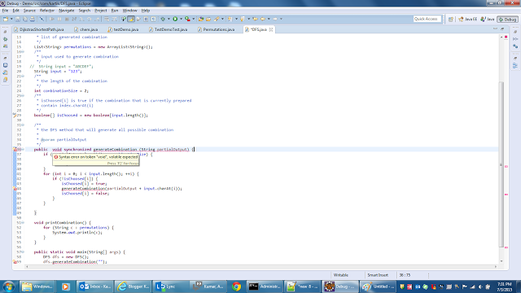

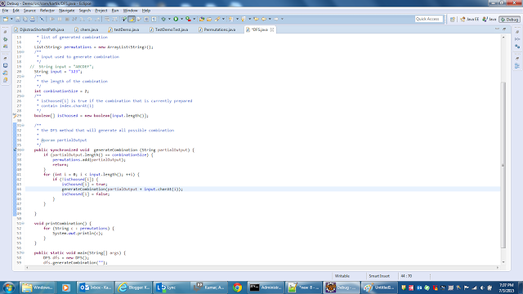
Read more at http://www.java2blog.com/2014/07/how-hashset-works-in-java.html#GFAVhlvi30QeJdCO.99

Wrapper Class
Introduction
Java is an object-oriented language and can view everything as an object. A simple file can be treated as an object (with java.io.File), an address of a system can be seen as an object (withjava.util.URL), an image can be treated as an object (with java.awt.Image) and a simple data type can be converted into an object (with wrapper classes). This tutorial discusses wrapper classes. Wrapper classes are used to convert any data type into an object.

Wrapper class in Java
Wrapper class in java provides the mechanism to convert primitive into object and object into primitive.
Since J2SE 5.0, autoboxing and unboxing feature converts primitive into object and object into primitive automatically. The automatic conversion of primitive into object is known and autoboxing and vice-versa unboxing.
One of the eight classes of java.lang package are known as wrapper class in java. The list of eight wrapper classes are given below:
Primitive Type | Wrapper class
boolean | Boolean
char | Character
byte | Byte
short | Short
int | Integer
long | Long
float | Float
double | Double

Why it is required
Wrapper classes are used to convert any data type into an object. The primitive data types are not objects; they do not belong to any class; they are defined in the language itself. Sometimes, it is required to convert data types into objects in Java language.

Custom wrapper
- We have a class IntVal, that has an int field, getter and setter for the field, a constructor using its field and a method, increment() that increases by one the int field. It also overrides the toString() method ofObject, and returns the String object that represents the int field.
- We create a new ArrayList and populate it with values, using add(Object o). The objects added to the list are IntVal objects.
- We get the elements of the list, that are Intval objects and useincrement() method of IntVal to increase the values of the objects.
Let’s take a look at the code snippet that follows:

package com.javacodegeeks.snippets.core;

import java.util.ArrayList;
import java.util.List;

class IntVal {

private int i;

public IntVal(int a) {

i = a;
}

public int getVal() {

return i;
}

public void setValue(int a) {

this.i = a;
}

public void increment() {

i++;
}

@Override
public String toString() {

return Integer.toString(i);
}
}

public class WrapperClass {

public static void main(String[] args) {

List list = new ArrayList();

for (int i = 0; i < 10; i++) {

list.add(new IntVal(i));

}

System.out.println(list);

for (int i = 0; i < list.size(); i++) {

((IntVal) list.get(i)).increment();

}

System.out.println(list);

}
}
Output:
[0, 1, 2, 3, 4, 5, 6, 7, 8, 9]
[1, 2, 3, 4, 5, 6, 7, 8, 9, 10]

Which is better?
That is like asking which is better a volley ball or a volleyball in a Fedex box. It depends what you want to do with it.
int vs Integer
ability | unboxed  int | boxed  Integer
Calculate with it, + - * / % ^ etc. | true | false
Pass it as a parameter | true | true
return it as a value | true | true
Use methods on it from java.lang.Integer | false | true
Store it in a Vector or other Collection | false | true
Use it as a HashMap key | false | true
serialize it | false | true
send it by itself over RMI (Remote Method Invocation) | false | true
send it as part of another Object over RMI | true | true
pass it as a generic object to a TableCellRenderer. You may pass a variety of different types via the same paramter. | false | true
Allow for a null value that means there is no value. | false | true

Converting

Marker Interface
Some examples of Java marker interfaces are :-
1) Serializable
2) Cloneable
3) RandomAccess
4) SingleThreadModel
5) EventListner
Marker interface in Java is interfaces with no field or methods or in simple word empty interface in java is called marker interface. Example of market interface is Serializable, Clonnable and Remote interface. Now if marker interface doesn't have any field or method or behavior they why would Java needs it? This was asked to my friend in one of his core java interview and then I thought to touch based on it. In this article we will see couple of reason on what marker interface do in Java and what is use of marker interface in Java. Marker interface are also called tag interface in Java.

What is Marker interfaces in Java and why required

Why Marker or Tag interface do in Java
1) Looking carefully on marker interface in Java e.g. Serializable, Clonnable and Remote it looks they are used to indicate something to compiler or JVM. So if JVM sees a Class is Serializable it done some special operation on it, similar way if JVM sees one Class is implement Clonnable it performs some operation to support cloning. Same is true for RMI and Remote interface. So in short Marker interface indicate, signal or a command to Compiler or JVM.

This is pretty standard answer of question about marker interface and once you give this answer most of the time interviewee definitely asked "Why this indication can not be done using a flag inside a class?” this make sense right? Yes this can be done by using a boolean flag or a String but doesn't marking a class like Serializable or Clonnable makes it more readable and it also allows to take advantage of Polymorphism in Java.

Where Should I use Marker interface in Java
Apart from using built in marker interface for making a class Serializable or Clonnable. One can also develop his own marker interface. Marker interface is a good way to classify code. You can create marker interface to logically divide your code and if you have your own tool than you can perform some pre-processing operation on those classes. Particularly useful for developing API and framework like Spring or Struts.
After introduction of Annotation on Java5, Annotation is better choice than marker interface and JUnit is a perfect example of using Annotation e.g. @Test for specifying a Test Class. Same can also be achieved by using Test marker interface.
Another use of marker interface in Java

One more use of marker interface in Java can be commenting. a marker interface called Thread Safe can be used to communicate other developers that classes implementing this marker interface gives thread-safe guarantee and any modification should not violate that. Marker interface can also help code coverage or code review tool to find bugs based on specified behavior of markerinterfaces.
Again Annotations are better choice @ThreadSafe looks lot better than implementing ThraedSafe marker interface.
Read more: http://javarevisited.blogspot.com/2012/01/what-is-marker-interfaces-in-java-and.html#ixzz3wlxzpxSE

Example of Custom Marker Interface

Example:
AGradeCollegeMarker.java
package com.javawithease.business;

/**
* This is marker interface for A grade college.
* @author javawithease
*/
public interface AGradeCollegeMarker {

}
College1.java
package com.javawithease.business;

/**
* This class represents a A grade college.
* @author javawithease
*/
public class College1 implements AGradeCollegeMarker{
//Do something
}
College2.java
package com.javawithease.business;

/**
* This class represents a, non A grade college.
* @author javawithease
*/
public class College2 {
//Do something
}
TestCollege.java
package com.javawithease.business;

/**
* This class is used to test the custom marker interface functionality.
* @author javawithease
*/
public class TestCollege {
static void tester(Object obj){
if (obj instanceof AGradeCollegeMarker) {
System.out.println("A grade college.");
}
}

public static void main(String args[]){
College1 obj1 = new College1();
College2 obj2 = new College2();

//test college objects
tester(obj1);
tester(obj2);
}
}

Output:
A grade college.
  - See more at: http://tutorialspointexamples.com/how-to-create-custom-marker-interface/#sthash.KELw8MFU.dpuf

for,for each,while are used for iterations.
for loop is used if you already know how many times the loop has to executed.
while is used when you do not know the number of times loop has to executed.
for each introduced in 1.5 version is used for iterating only the elements in arrays,collections.
ex:
?
1  2  3  4  5 | int b[]={1,2,3};  for(int a:b)  {  System.out.println(a);  }

Exam
Recently, more and more illegal street races have been spotted at night in the city, and they have become a serious threat to public safety. Therefore, the Police Chief has decided to deploy speed cameras on the streets to collect evidence.
There are N+1 intersections in the city, connected by N roads. Every road has the same length of 1. A street race may take place between any two different intersections by using the roads connecting them. Limited by their budget, the police are able to deploy at most K speed cameras on these N roads. These K speed cameras should be installed such that the length of any possible street race route not covered by speed cameras should be as short as possible.
You are given a map of the city in the form of two zero-indexed arrays, A and B of length N, and an integer K:
- For each J (0 ≤ J < N) there is a road connecting intersections A[J] and B[J].
The Police Chief would like to know the minimum length of the longest path out of surveillance after placing at most K speed cameras.
Write a function:
int solution(int A[], int B[], int N, int K);
that, given arrays A and B of N integers and integer K, returns the minimum length of the longest path unmonitored by speed cameras after placing at most K speed cameras.
For example, given K = 2 and the following arrays:
A[0] = 5 B[0] = 1 A[1] = 1 B[1] = 0 A[2] = 0 B[2] = 7 A[3] = 2 B[3] = 4 A[4] = 7 B[4] = 2 A[5] = 0 B[5] = 6 A[6] = 6 B[6] = 8 A[7] = 6 B[7] = 3 A[8] = 1 B[8] = 9
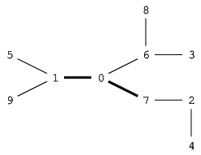
the function should return 2. Two speed cameras can be installed on the roads between intersections 1 and 0 and between intersections 0 and 7. (Another solution would be to install speed cameras between intersections 0 and 7 and between intersections 0 and 6.) By installing speed cameras according the first plan, one of the longest paths without a speed camera starts at intersection 8, passes through intersection 6 and ends at intersection 3, which consists of two roads. (Other longest paths are composed of intersections 5, 1, 9 and 7, 2, 4).
Assume that:
- N is an integer within the range [1..50,000];
- each element of arrays A, B is an integer within the range [0..N];
- K is an integer within the range [0..N];
- the distance between any two intersections is not greater than 900.
Complexity:
- expected worst-case time complexity is O(N*log(N));
- expected worst-case space complexity is O(N), beyond input storage (not counting the storage required for input arguments).
Elements of input arrays can be modified.
Copyright 2009–2016 by Codility Limited. All Rights Reser

